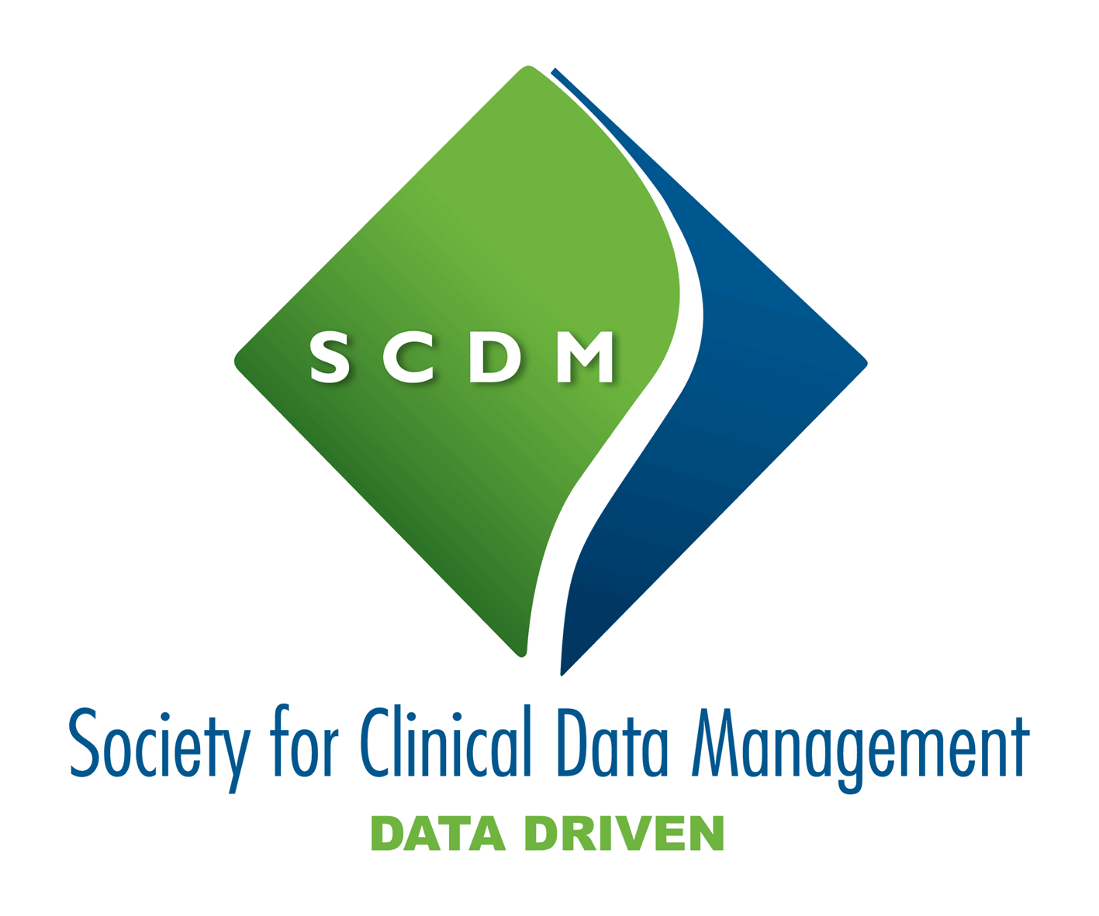

SCDM Organizational Membership Application
Section A: Company Information
Company: ______________________________________________________________
Contact Name:___________________________________________________________
Contact E-mail: __________________________________________________________
Business Address: ___________________________________________________________________
City: _________________________ State: ____________________ Zip/Postal Code:_____________
Country: ______________________ Tel: (_____)_______________ Fax: (_____)_________________

Mailing Address: ____________________________________________________________________
City: _________________________ State: ____________________ Zip/Postal Code:_____________
Country: ______________________ Tel: (_____)_______________ Fax: (_____)_________________
Section B: Member Company Information
Employer Type:

Academic Health Center
Biotechnology
Centralized Laboratory
Consulting Firm
Contract Research Organization (CRO)
Hospital
Medical Device/Diagnostic/Imaging
Other
Pharmaceutical
Recruiter
Regulatory Agency
Site Management
Vendor

Section C: Membership Type
High Income County $125 per unit. Number of units required: ________
Middle Income Country $80 per unit. Number of units required: ________
Lower Income Country $40 per unit. Number of units required: ________
Section D: Payment Information
TOTAL AMOUNT DUE $________
Check Enclosed
Please make all checks payable to SCDM. Please do not send cash.
Visa MasterCard American Express
Credit Card Number ______________________________________________________
Expiration Date (month/year): _______________
Cardholder’s Name _______________________________________________________
Cardholder’s Signature ____________________________________________________
Wire Transfer (Please do not forget to mention the invoice number)
Bank Name: ING Belgium
Bank Account holders name: SCDM
IBAN Code: BE78310177451886
BIC: BBRUBEBB100
Bank account holder’s address: Boulevard du Souverain 230, 1160 Brussels, Belgium

Please fill in the names of all delegates:
Full Name | Email address | County
If more than, please use a separate sheet!
One person from the company will be appointed as the Group Contact for administrative purposes. The Group Contact may or may not be a delegate.

Return to:
Americas | India | Global Headquarters | China
Society for Clinical Data Management  7918 Jones Branch Drive  Suite 300  McLean, VA 22102  Tel: 703-651-8188  Fax: 703-506-3266  info-am@scdm.org | Society for Clinical Data Management  203, Wing B, Citipoint  (Near Hotel Kohinoor Continental)  J. B. Nagar, Andheri-Kurla Road  Andheri (East). Mumbai – 400059  Tel: +91 22 61432600  Fax: +91 22 67101187  info-in@scdm.org | Society for Clinical Data Management  Boulevard du Souverain, 280  B-1160 Brussels, Belgium  Tel: +32-2-320 2529  info@scdm.org | Society for Clinical Data Management  Level 4 Puxi Management Center  No.801 Jumen Road  Shanghai 200023  China  Phone: +86-21-2312 3523  Fax: +86-21-2312 3699  info-cn@scdm.org
www.scdm.org

